31. Practice creating following tables MySQL syntax: create table mydept_DBDA ( deptid int primary key, dname varchar(20) not null unique, dloc varchar(20) )

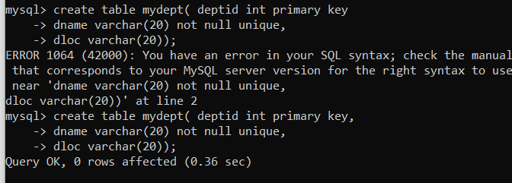



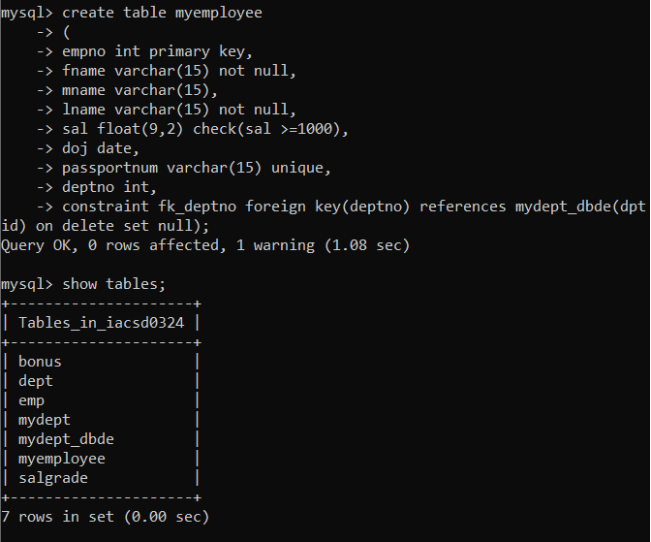

**32. Create following tables Student, Course Student (sid,sname) ---------------- sid ---primary key Course(cid,cname)-------------- cid ---primary key Marks(studid,courseid,marks) Sample data for marks table studid,courseid,marks**